**KMS service tooling**

**Aim:**

* **To develop a springboot web application which will read user name and prints “Hello {username}”.**
* **To understand micro service architecture and containerization - Docker.**
* **To deploy the two sidecar container on k8s and access them with main container.**

**Procedure:**

**Step 1: Create a simple springboot app which will accept username and displays hello “{username}”**

main container-8080

sidecar1(capitalize) - 8085

sidecar2(camelcase) - 8090

**Step 2: Create a docker file**

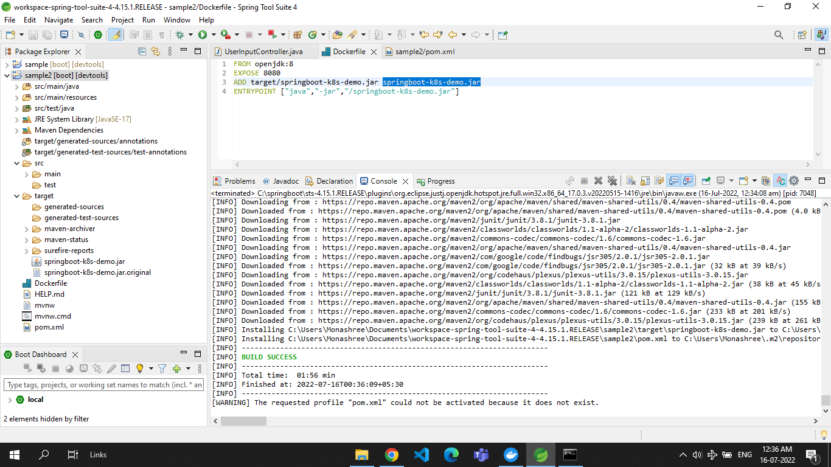

**Step 3: start minikube**

minikube start --driver=docker

minikube status

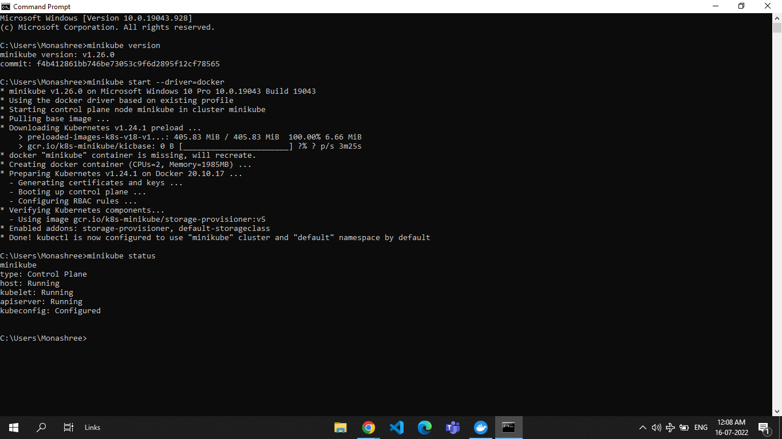

**Step 4: Setup docker environment and build docker images**

minikube docker-env

docker build –t springboot:1.0 .

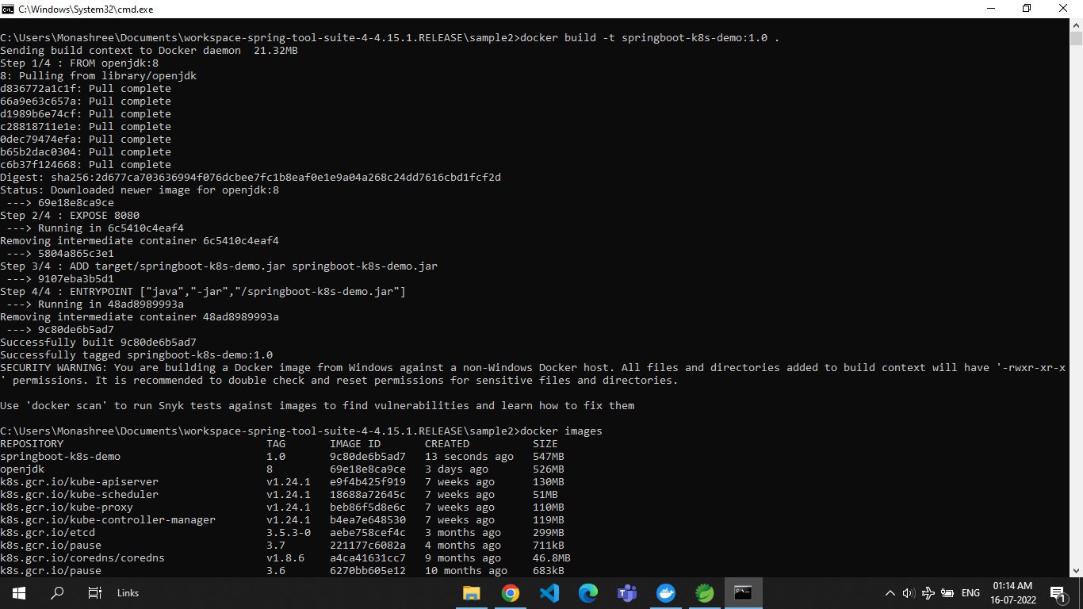

**docker images**

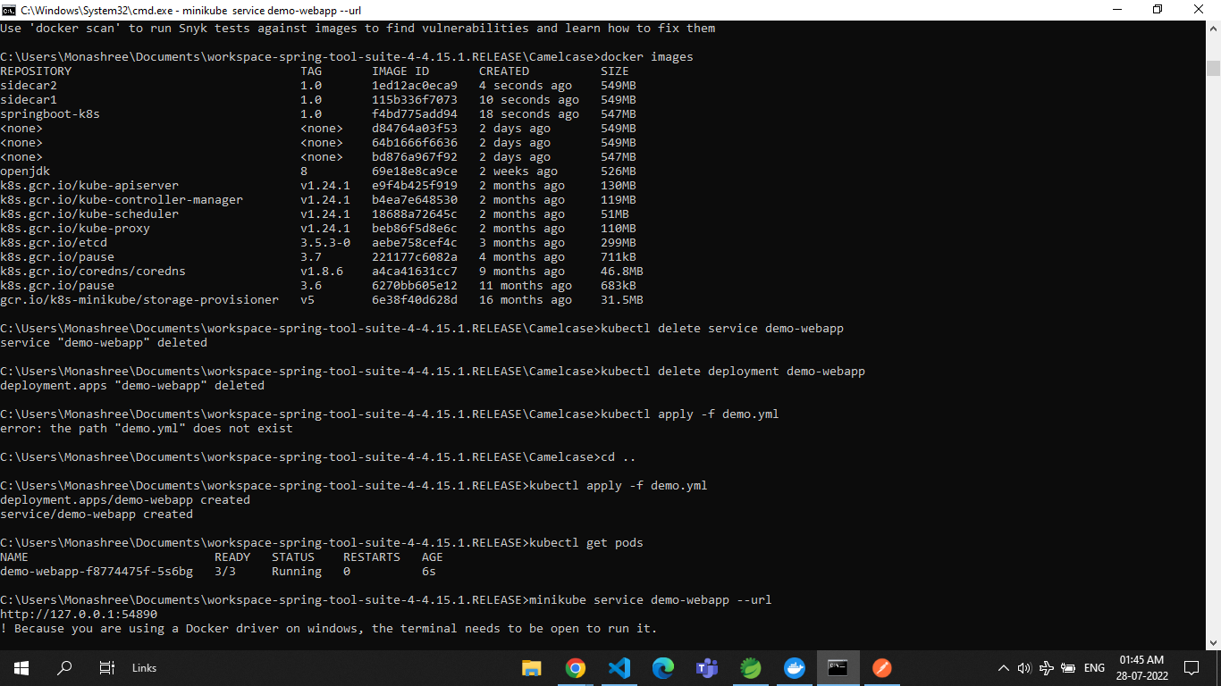

**Step 5: Create yml file**

apiVersion: apps/v1

kind: Deployment

metadata:

  creationTimestamp: null

  labels:

    app: demo-webapp

  name: demo-webapp

spec:

  replicas: 1

  selector:

    matchLabels:

      app: demo-webapp

  strategy: {}

  template:

    metadata:

      creationTimestamp: null

      labels:

        app: demo-webapp

    spec:

      containers:

      - image: sidecar1:1.0

        name: sidecar-container1

        imagePullPolicy: IfNotPresent

        resources: {}

      - image: sidecar2:1.0

        name: sidecar-container2

        imagePullPolicy: IfNotPresent

        resources: {}

      - image: springboot-k8s:1.0

        name: main-container

        resources: {}

        imagePullPolicy: IfNotPresent

      volumes:

      - name: var-logs

        emptyDir: {}

status: {}

---

apiVersion: v1

kind: Service

metadata:

  name: demo-webapp

  labels:

    run: demo-webapp

spec:

  ports:

  - port: 8080

    protocol: TCP

  selector:

    app: demo-webapp

  type: NodePort

**Step 6: Deploy it on k8s**

Kubectl apply –f demo.yml

kubectl get deployment

kubectl describe deployment demo-webapp

kubectl get pods

kubectl get service

minikube service demo-webapp –url



kubectl logs demo-webapp-8689dc9df5-sq858

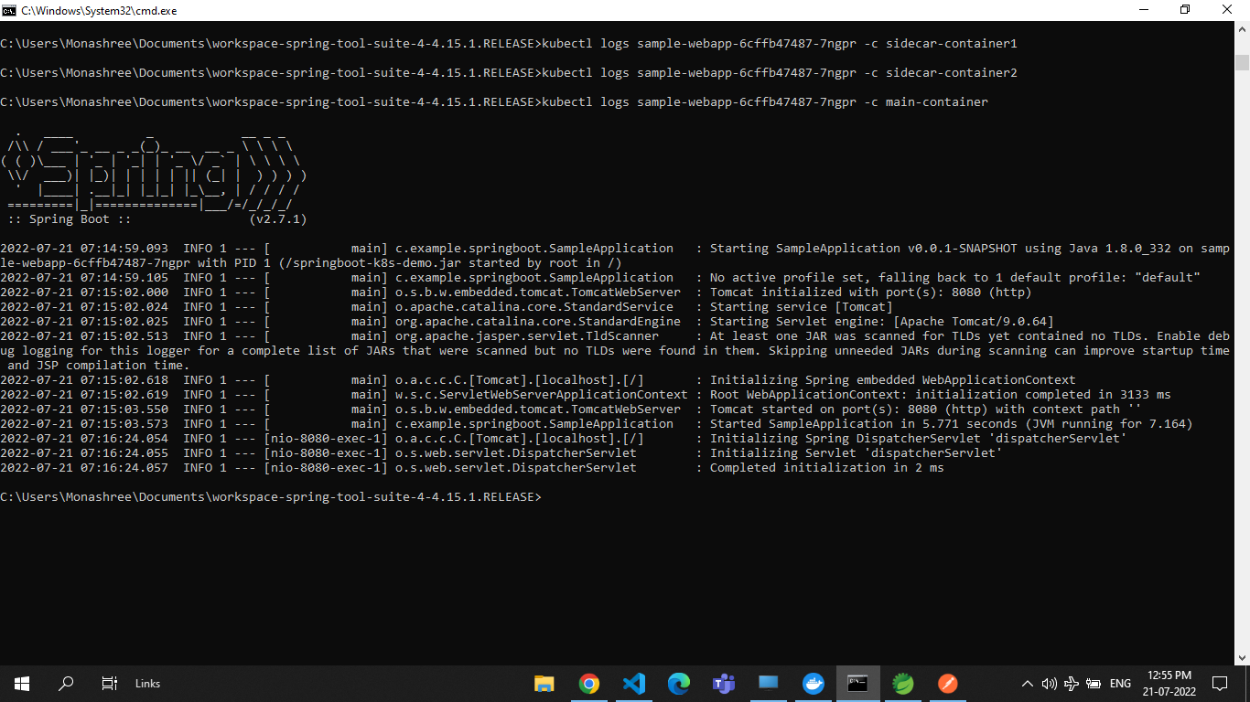

**Step 7: Test it on postman**

